Report-4

Work Progress:- I have completed my project.

About My Website :- In total I have 4 pages(web pages). The first one is the main page/landing page which consists of about us, social icons for contact, speciality of restaurant, menu card, copyright etc. The main page is linked with 2 more web page. When you click on “gallery” in main page, it lands to another web page called “gallery”. The gallery contains 30 photos of dishes with their appropriate content. The contents are visible only when you hover over the image. Again, when you click on “Explore” in the main page, it lands up to another page named “Explore”. This “Explore” page contains the logo (It is a styled text instead of an Image because restaurants generally have styled text as their logo), the nav bar and the location of the restaurant. The “Explore” page of the restaurant has 4 more links. Out of those 4 links, 3 links will take the user back to the main page because the contents are in the main page and the other link for “contact” will open in another page providing the user with a “contact us” form(since for contact I have already used social icons in the main page). All the pages have some cool transitions and transformation.

Credits:- Pexels(for images), Wikipedia(for text But 50% text were mine and rest Wikipedia), W3 school (for how to use animation and media query), google fonts(for font-style), font awesome(for icons).

Website Composition :- HTML, CSS, JS

Responsive :- All the pages are responsive.

Uploaded the code in Hosting Repository :- Yes

Glimpses of my website :-

1. Main page/Landing page

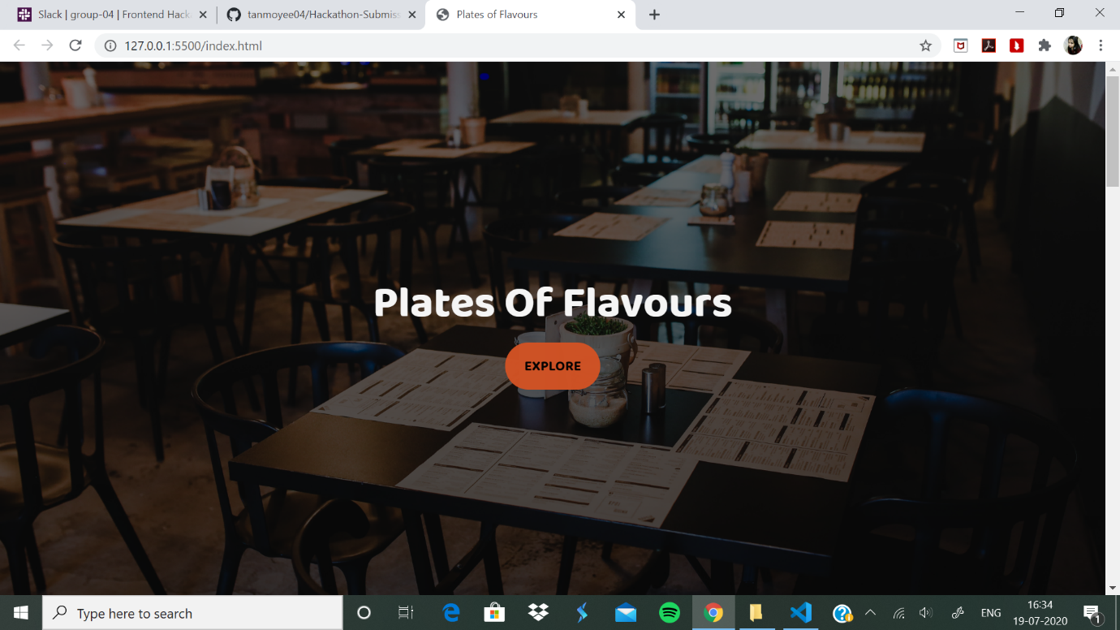

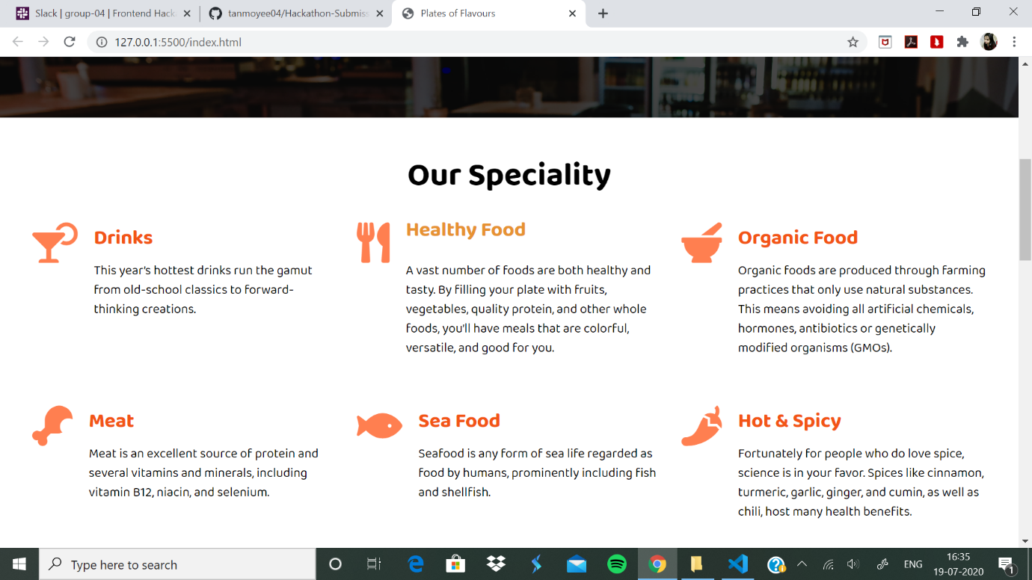

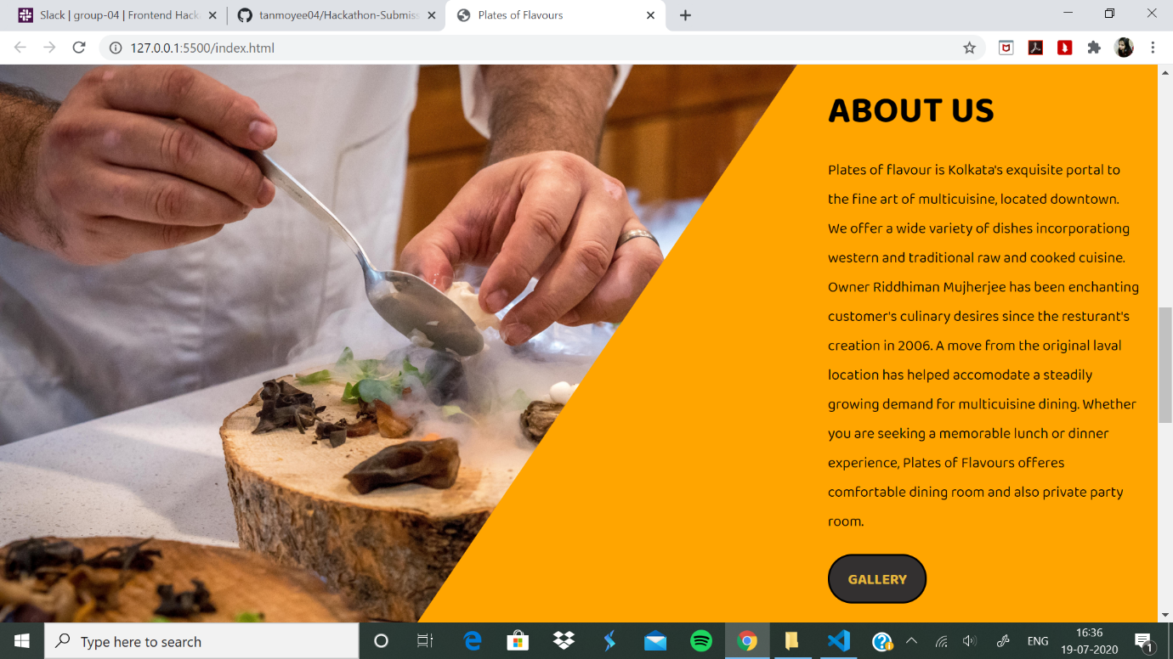

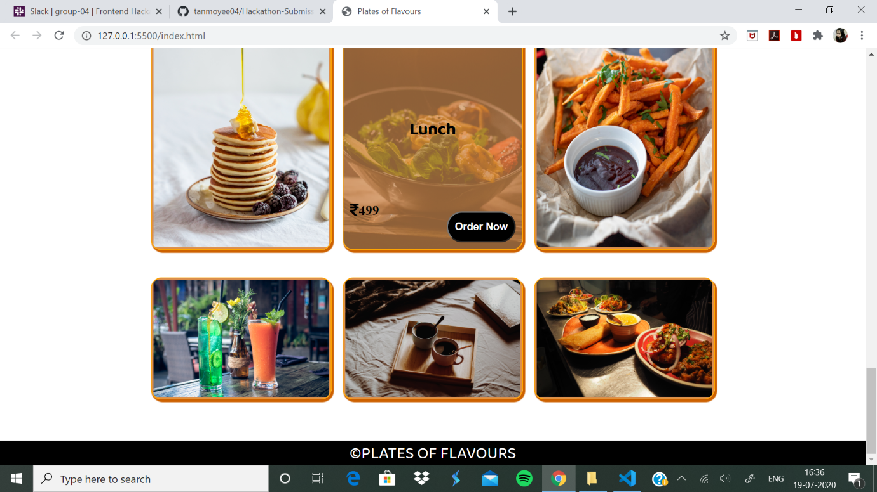

1. Explore Page that opens when clicked on “Explore”

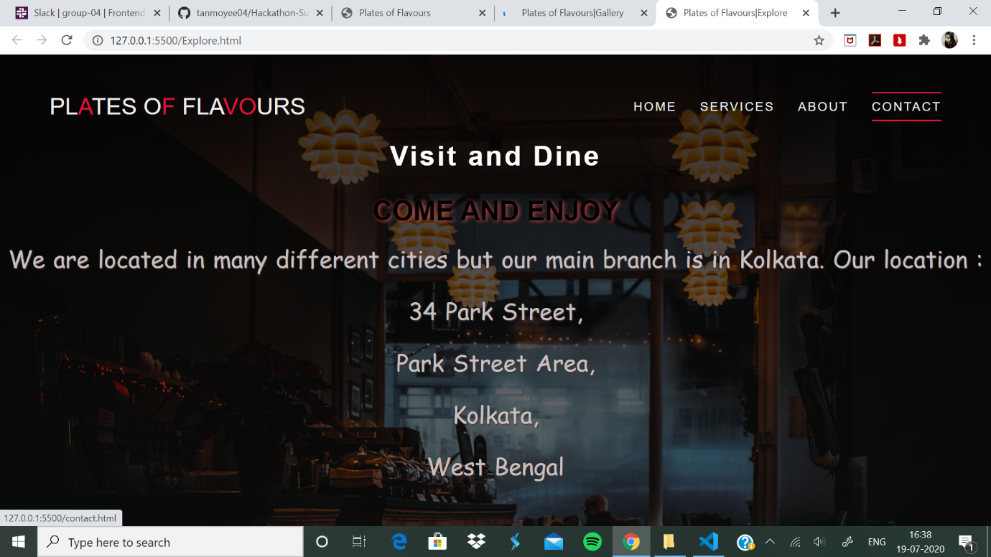

1. Gallery page that opens when clicked on “Gallery”

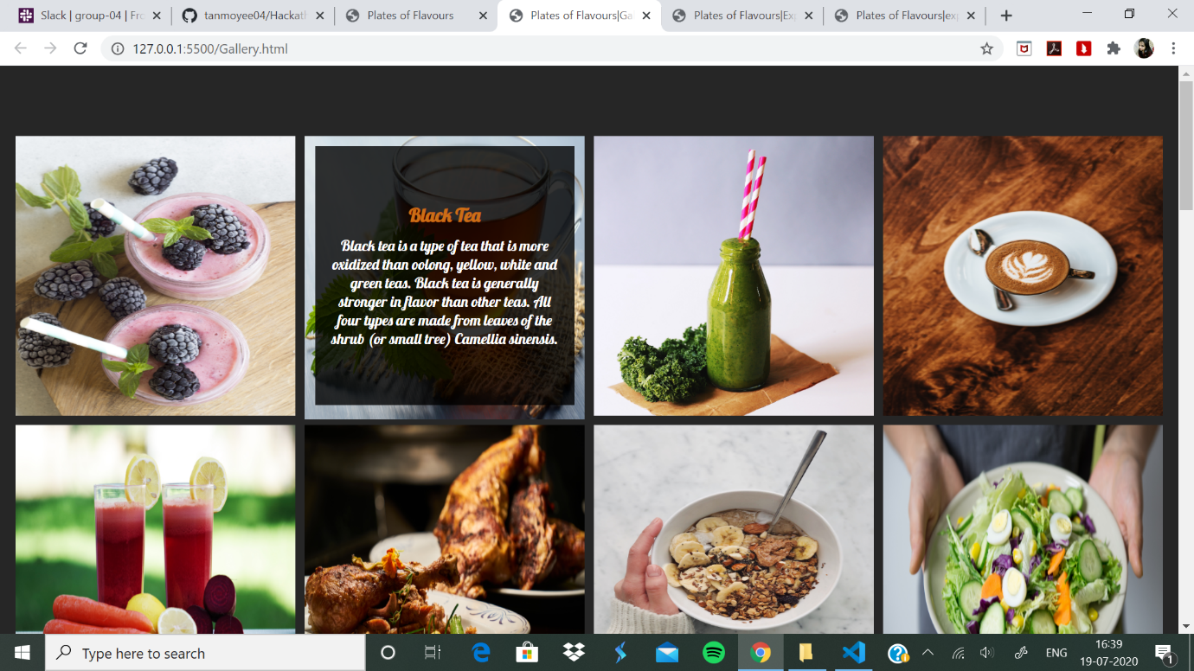

1. Contact page when clicked on “contact” in the explore page’s navbar

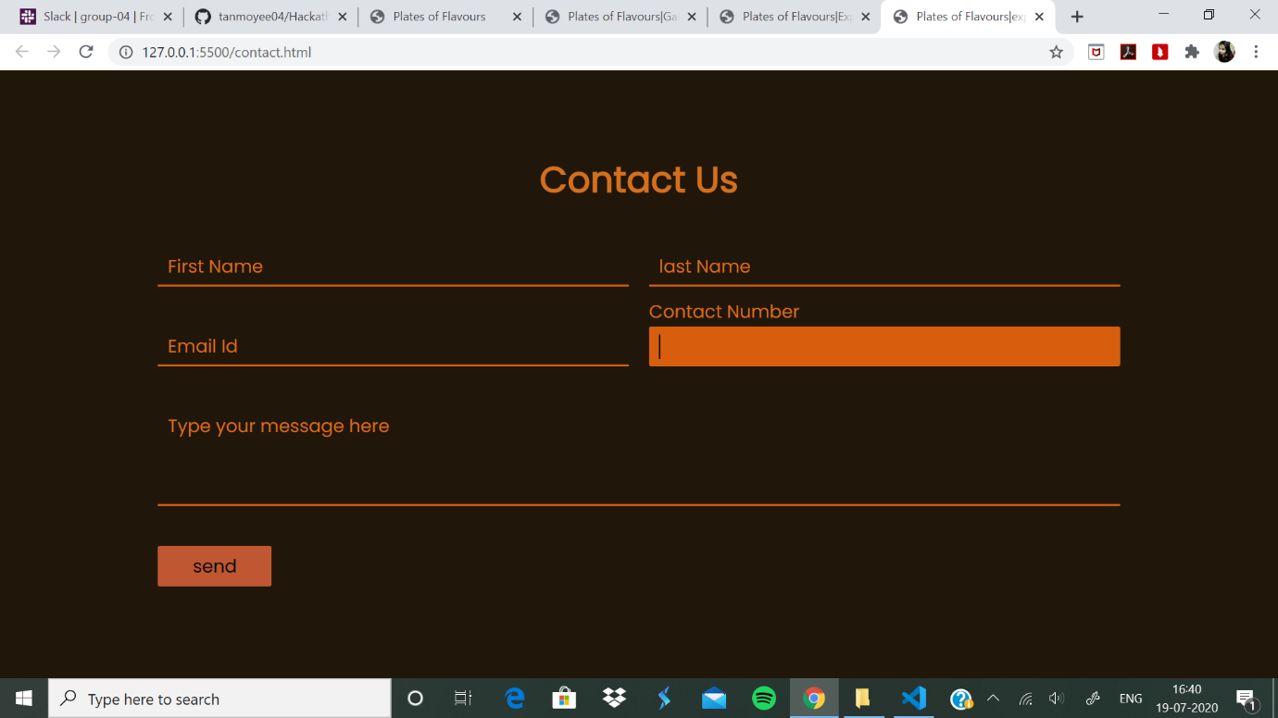

NOTE:- Do click on all the links in all the web pages and also check those icons and writings, over which if you hover, the cursor changes to pointer and some effects are shown.